Tool Guide – Amass

Introduction
Amass is a reconnaissance tool used for network mapping and attack surface discovery. Its primary focus is subdomain enumeration but also helps with mapping IP ranges and organisations.
Safety Disclaimer: Use only on networks and systems for which you have explicit authorisation. Unauthorized use of tools can be Illegal, unethical and harmful.

Setup and Launch
  - Step1: Open Deakin Detonator Toolkit
- Open Terminal in Linux
- Navigate to your Deakin Detonator Toolkit directory: (cd ~/Deakin-Detonator-Toolkit)
- Run DDT by using the following command line: (yarn run tauri dev)
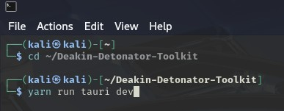
  - Step2: Find Tool-example
- Click on Tools to the left (or use the quick search bar)
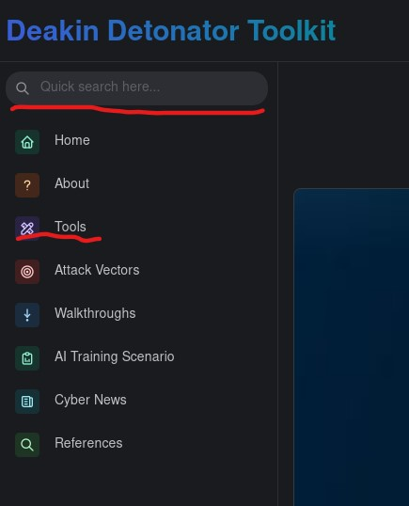
- If you clicked on Tools, scroll down and find Amass and click go

Configuration and Usage
  - Step3: Configuring Amass
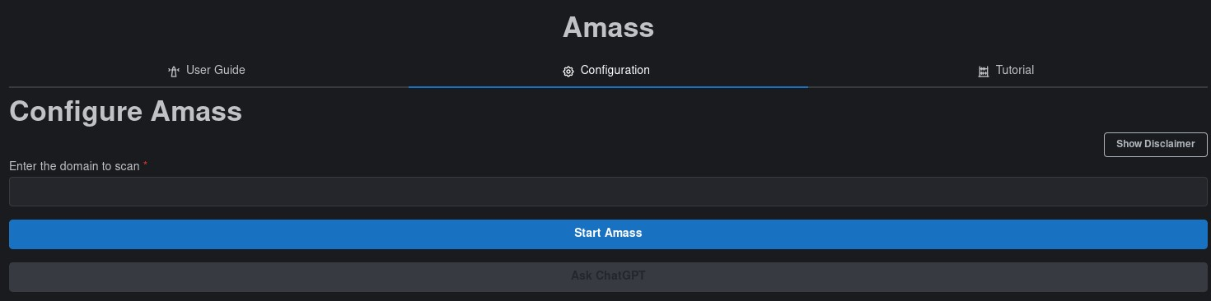
- Enter the domain you wish to use Amass on, e.g. “example.com”
  - Step4: Results
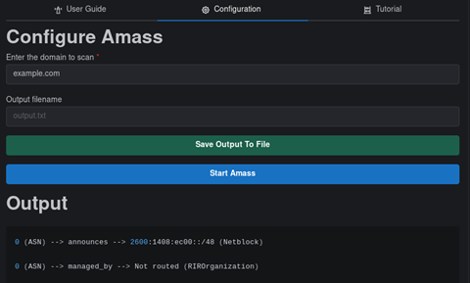
- You will be given an output that should end with “process completed successfully” and be sure to scroll up in the Output field to see the rest.
- Optional: You can save your output by filling out the new “Output filename” field with an appropriate name (output.txt) and then clicking “Save Output To File” button
- Optional: You can copy your output to your clipboard by clicking the little clipboard in the top-right of the output area.

Output Explanation
Note: your output will naturally be dependent on what domain you used, the following is non-comprehensive example output of what you should get from using amass on domain “example.com”.
- Amass enum -d example.com
  - This is what you would use in terminal/cli to run amass
- example.com (FQDN) --> ns_record --> b.iana-servers.net (FQDN)
  - FQSN is Fully qualified Domain Name
  - Ns_record, Name server record
- example.com (FQDN) --> a_record --> 23.220.75.245 (IPAddress)
  - a_record is address record
  - resolves the domain to an IP address (a_record for IPv4, aaaa_record for IPv6)
- 199.43.135.0/24 (Netblock) --> contains --> 199.43.135.53 (IPAddress)
  - Netblock, shows a range of Ips an address belongs to.
- 26710 (ASN) --> managed_by --> ICANN-ANYCASTED-SERVICES - ICANN (RIROrganization)
  - Asn, identifies the organization that owns/operates the IP space.

